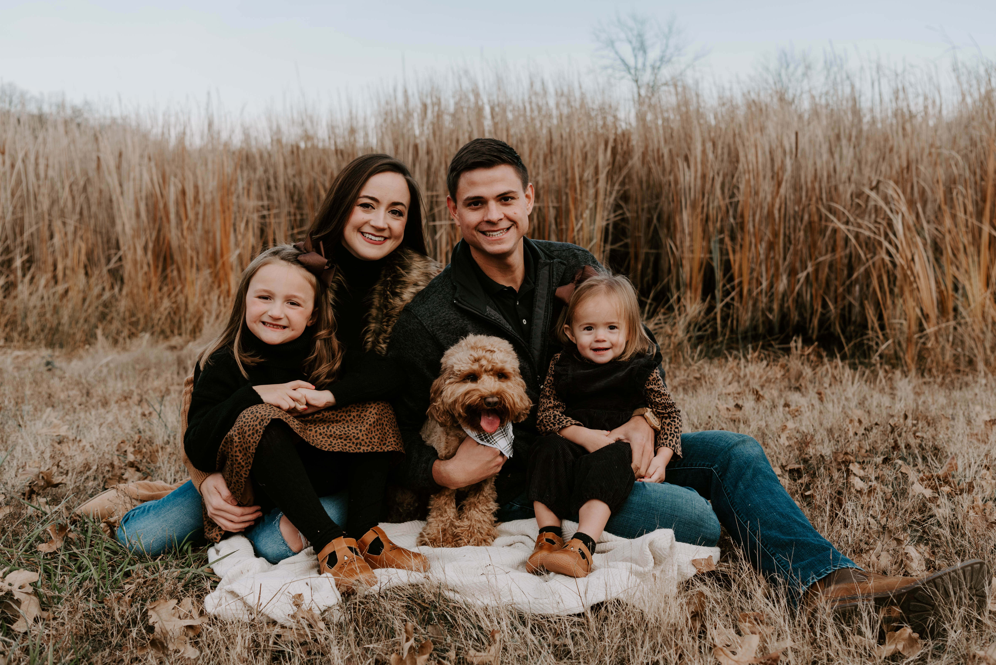
The Kindred Doodle Co.
Official Puppy Contract

Dog Information
Breed: Australian Labradoodle
Sex: M/F
Color:
D.O.B:
Name:
Microchip:
Sire: FairyTale Lane Old Soul Pappy
Dam: ClearWater Nala Brown

Pricing
Date Sold:
Puppy Price: $3,000 (subject to taxes and fees if not cash/check)
Delivery Fees/Extended Stay (if applicable):
Total Balance:
*Seller has the right to cancel/refuse sale at anytime if the seller feels it is in the best
interest of the puppy.

Contract/Agreement
The Dog sold pursuant to the terms of this agreement is a multi generation Australian Labradoodle understood to be companion pet only and not sold as a breeding prospect.
Kindred Doodle guarantees the health of puppy at time of sale and against any severe or life-threatening hereditary diseases up the age of 24 months. This health guarantee is only valid between the seller and original buyer, and does not transfer if ownership of the dog changes. We offer lifetime support with all of our puppies and if puppy is no longer wanted, we will take any of our puppies back from anyone at any time. (No cash refund)
The Kindred Doodle puppy is guaranteed to be in good health at time of sale and buyer will have puppy examined by their veterinarian within 3 days of receiving their puppy. If buyer’s veterinarian finds the puppy to have chronic or serious health issues, buyer may immediately return the puppy along with a report issued by the Veterinarian and Kindred Doodle will replace the puppy with another puppy from the next available litter. The following circumstances are not considered a chronic or serious health issue: Bordetella, worms, ticks, fleas, mites, cocci, giardia, or other parasites as they are common in dogs and puppies.
(Breeder's Choice) Any request for replacement must be made within the 3 day time period and failure to have the puppy examined by buyer’s Veterinarian within 3 days will make this contract void.
Conditions:
1. If a hereditary disease is diagnosed, it must be designated severe, or life threatening, diminishing the quality of puppy/dog’s life, and be confirmed by two independent veterinarians. Findings will be sent to Kindred Doodle including diagnostic data, x-rays, etc. and must be reviewed and agreed upon by a Veterinarian of Kindred Doodle’s choosing. The Kindred Doodle Co reserves the right to have puppy/dog examined by a veterinarian of our choosing at our expense.

2. In the case of Hip dysplasia, proof by the Orthopedic Foundation for Animals (OFA) is
required before any replacement/refund will be made.

3. In the case of hip dysplasia, the health guarantee is void if the puppy’s primary diet has not
been a premium food, and/or puppy has been allowed to become overweight.

4. In the case of any eye disease, the dog’s eye exam must be sent to the Canine Eye
Registration Foundation (CERF) for judgment, and the statement confirming a debilitating
disease sent to KDC.

5. Puppy must have been kept current on yearly exams, heartworm tests
and preventative, all vaccines, and rabies. This health guarantee will be void if buyer unable to
provide complete and accurate copies of their puppy’s health care given on a regular basis.

6. If the puppy has been allowed to compete in Agility, run up and down stairs, or be a jogging partner, before the age of 12 months, this health guarantee will be void.

7. A dog that has been physically injured is not covered under this health guarantee.

8. It is the buyer’s responsibility to keep the puppy away from public places (such as puppy
kindergarten, pet stores, dog parks, etc.) before they are fully vaccinated to reduce the risk of
deadly viruses (such as Parvovirus). Failure to do so, should puppy be diagnosed with deadly
virus, will void this health guarantee.

If all of the conditions of this agreement have been met, and the buyer desires to return the medically diagnosed dog, Kindred Doodle will have the option at our discretion to replace the puppy from the next available litter. Upon replacing the pup buyer will pay the additional $750 of original price of new puppy. Return shipping of the old puppy, and shipping of the new puppy will be at buyer’s expense. If the buyer desires to keep the puppy, Kindred Doodle will pay for all Veterinary costs for treatment up to the full purchase price of the puppy paid to buyer’s Veterinarian.

Kindred Doodle offers lifetime support with all of our puppies. If at any time buyer decides he/she no longer wants puppy/dog, or can no longer care for it, we will take puppy/dog back at any time, for any reason, with no refund. If at any time buyer should choose to re-home puppy/dog, buyer agrees to contact seller to help place puppy/dog in new home. At no time should this puppy/dog be surrendered to the SPCA, Humane Society, dog pound, etc.

Your puppy has already been spayed/neutered (ESN): yes____ no____
(if no, buyer agrees to spay puppy at 8 months old and agrees to the conditions that follow)

Buyer Agrees to Spay/Neuter. The buyer understands this puppy is being sold as a pet and
under no circumstances will be bred. The breeding of this puppy/dog is NOT an option. The
puppy must be spayed or neutered by 6 months of the signed contract. Buyer agrees to furnish Kindred Doodle with a spay/neuter certificate within 2 weeks of spay/neuter deadline, at which time sale of the puppy is complete and ownership officially the buyer’s. If buyer does not provide proof of spay/neuter signed by a licensed Veterinarian within the allotted time period, or if the dog has been bred by purpose or accident, buyer agrees to immediately pay the sum of $10,000, which is the average cost of a Labradoodle breeding dog. Furthermore, buyer agrees to pay Seller $2,200 per puppy should any puppies be born as a result of failure to spay/neuter. Buyer also agrees to relinquish all rights of dog and it’s offspring (if applicable) should the dog be bred in breach of this contract, and the seller has the right to reclaim the dog and it’s offspring (if applicable).

By signing below, the buyer is indicating in a legally binding way that they have read, understand and agree to all conditions and terms set forth in this agreement. The buyer further understands and agrees that any breach of this contract by the buyer may result in repossession of the above-mentioned puppy/dog by seller. Any expenses, incurred by seller to enforce this agreement shall be the responsibility of the buyer, including but not limited to: legal expenses, other fees, mileage, costs involved with reclaiming/repossessing puppy/dog, etc. All terms, and health guarantees shall be considered null and void should the buyer be in breach of any portion of this agreement. No refunds will be issued by the seller if the buyer voluntarily relinquishes ownership for any reason, or if any breach of agreement by the buyer results in repossession of the above-named puppy/dog. All court claims will be held in Cleburne County Arkansas.

Date:__________________________________________________________________________
Buyers Signature:________________________________________________________________
Buyer/Buyers Name (printed):______________________________________________________
Sellers Signature: Lauren Brown
Date:___________________________________________________________________________

